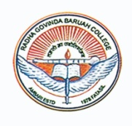R.G.BARUAH COLLEGE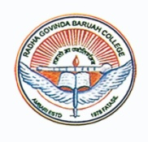
FATASIL AMBARI, GUWAHATI-781025
ADMISSION NOTICE: 2022-23

Online /Offline applications are invited for admission into B.A and B.Com courses for the Academic session 2022-23. Eligible candidates are advised to go through the College website www.rgbaruahcollege.ac.in for online access to the form & prospectus and other details. Candidates may also visit college office for collection of form & prospectus for offline application.
COURSE | DATE OF ISSUE OF FORM | LAST DATE OF SUBMISSION OF FORM | PUBLICATION OF MERIT LIST | DATE OF ADMISSION
BA 1st Semester | 01-07-2022 | 18-07-2022 | 21-07-2022 | 22-07-2022
B.Com 1st Semester | 01-07-2022 | 18-07-2022 | 21-07-2022 | 23-07-2022
- Merit list will be uploaded in the College website.
- Free Admission scheme is applicable for domicile students of Assam only.
- For details visit the College website: www.rgbaruahcollege.ac.in

Sd/-
Dr. Pranjit Kumar Nath
Principal
R.G.Baruah College
Guwahati-781025

